OFFICIAL COORDINATION REQUEST FOR
NON-ROUTINE OPERATIONS AND MAINTENANCE

COORDINATION TITLE – 16 LWG 010 - Lower Granite Juvenile Bypass System Upgrade Schedule Update
COORDINATION DATE – 10 August 2016
PROJECT – Lower Granite Lock and Dam
RESPONSE DATE – August 19, 2016

Description of the problem - The Lower Granite Lock and Dam Juvenile Bypass System (JBS) is currently being upgraded to improve downstream fish passage. Construction of the JBS upgrade began in October 2014 and was originally slated to be completed for the 2017 fish passage season.

The Corps, with input from the Fish Facility Design Review Work Group (FFDRWG), has decided to extend project completion to 24 March 2018. This schedule slip is due to a variety of factors including unanticipated site conditions, the need to incorporate additional design features associated with the selected routing of the new primary bypass outfall, and additional time necessary to complete reviews of contractor submittals.

This MOC updates the overall project schedules and coordination efforts to date, primarily described in the following MOC’s (See Table 1 for list of MOC’s relating to overall JBS Upgrade effort):
- 13 LWG 17 Juvenile Fish Collection Channel Upgrade
- 15 LWG 004 Lower Granite Juvenile Fish Collection Channel Upgrade Update
- 15 LWG 025 LGR JBS Primary Outfall Construction

Type of outage required – Based on the current, revised schedule, Lower Granite Dam’s JBS will be taken out of service according to the following schedule (see Figure 1):

2016/17 JBS Winter Maintenance Window: 15 November 2016 to 24 March 2017
2017/18 JBS Winter Maintenance Window: 1 August 2017 to 24 March 2018

2016/17 In-Water Work Window: 15 November 2016 to 28 February 2017
2017/18 In-Water Work Window: 15 November 2017 to 28 February 2018

Turbine Unit Priority Changes (FPP Table LWG-5. Lower Granite Dam Turbine Unit Operating Priority Order):

1 Day - November 2016, November 2017 – Deviate from FPP specified turbine unit priorities, and voluntary spill operations as described elsewhere herein and MOC 13 LWG 17, for up to 1 day annually to determine suitable tailrace conditions for in-water construction work. The 1 day of testing is anticipated to last no longer than 8 daylight hours prior to the start of in-water construction activities in the Lower Granite Dam tailrace.

15 November 2016 – 15 December 2016: Deviate from FPP specified priorities for up to 3 days to facilitate construction of outfall structures.

15 November 2017 to 15 December 2017: Deviate from FPP specified priorities for up to 3 days to facilitate construction of outfall structures.

Extended JBS Outage Spill Operations – As a result of these schedule changes, the previously coordinated RSW spill operations associated with the extended JBS outage will occur during the extended 2017/18 outage. As previously coordinated, the Corps will operate the RSW 12 hours per day (6 am to 6pm) from 1 September to 15 December (i.e., Daytime Hours) if there is sufficient water to operate the RSW and maintain minimum generation (total project outflow ≥ approximately 19 kcfs).

During 15 November to 15 December 2017, it may be necessary to deviate from the agreed to 6.8kcfs RSW spill to support in-water construction activities associated with outfall construction. Changes to spill operations will be coordinated with project and RCC staff in the following order:
  - Continue daytime (6 am to 6 pm) RSW operations as proposed in FPOM MOC 13 LWG 17.
  - Operate the RSW from 6 pm to 6 am during construction periods.
  - Pass approximately 6.8 kcfs (4 stops) for 12 hours per day through 2 bays in a manner that facilitates safe tailrace conditions for construction activities while providing larger spillbay openings for adult salmonids that may be passing through this spill route. This modified bulk pattern will be implemented initially in bays 6 and 8 and, if necessary, subsequently adaptively managed in coordination with RCC and Lower Granite Dam operators to facilitate suitable tailrace conditions.
  - Pass approximately 6.8 kcfs (4 stops) for 12 hours per day through a non-RSW spill pattern in accordance with the proposed FPP Change Request Form “16LWG005 - Low Flow Spill Patterns w/ No RSW”
  - Pass a reduced amount of water (1-3 stops; 1.7 – 5.1 kcfs) for 12 hours per day that allows for safe in-water work conditions through a non-RSW spill pattern in accordance with the proposed FPP Change Request Form “16LWG005 - Low Flow Spill Patterns w/ No RSW”
  - Terminate spill during periods when spill operations described herein (MOC 13 LWG 17, 15 LWG 023) conflict with in-water construction activities. If feasible, the Corps will only terminate spill for the duration necessary to support construction activities (e.g., less than 12 hours of spill may be possible on a daily basis).
  - If it is necessary for the Corps to implement these steps, the Corps will prioritize the operation during the hours of 6 am to 6pm first and 6 pm to 6 am second when necessary to support construction activities.
- If the Snake River Zero Discharge operation is triggered to begin before December 15, nighttime spill operations would preclude the ability to reduce Lower Granite to zero discharge.

Impact on facility operation –
- The JBS will be out of service as described above. Removal of Lower Granite’s ESBS are anticipated to begin on the first day of the respective JBS outage window. The JBS will be returned to service by the end of the respective outage window in accordance with Fish Passage Plan (FPP) requirements.
- During the 2016/17 winter maintenance window of 15 November 2016 to 24 March 2017, mining of the juvenile collection channel to the final 9.5’ channel width will be continued through Units 3 and 4 (Units 5 and 6 were widened during the 2015/16 winter maintenance window). The collection channel will be tapered back to the existing channel width within NFMS acceleration requirements.
- During the extended winter maintenance window 1 August 2017 to 15 December 2017, approximately 6.8k kcfs will be spilled through the RSW (see 13 MOC 17 and 15 LWG 023 for previous coordination efforts). This spill may be adjusted as described above, including requirements to meet minimum generation requirements and from 15 November to 15 December 2017 if necessary to support in-water work activities associated with outfall construction efforts as described above.
- In-water work windows will coincide with JBS outage periods such that impacts to construction activities associated with JBS operations will be limited (e.g. JBS water discharges).
- Adult ladder outages are anticipated to follow FPP outage guidelines for the purposes of this JBS project.
- The existing outfall will remain in place and operation until the 2017/18 in-water work window.
- Turbine units may need to be operated outside of FPP priority order (FPP Table LWG-5) for limited durations as described above. Changes to turbine unit operations will be coordinated with project staff and RCC as necessary. As a note, FPP Table LWG-5 will be revised when repairs to Unit 1 are completed. Unit 1 is currently anticipated to return to normal operations in early 2017.

Dates of impacts/repairs – See Figure 1 below for construction and outage dates.

Length of time for repairs – All construction activities associated with the JBS Phase 1 upgrade are anticipated to be completed prior to the 2018 fish passage season.

Expected impacts on fish passage – Expected impacts to fish passage have been generally described through previous MOC’s and discussed in NWW FFDRWG meetings.
For the upcoming in-water work windows, in-water work will primarily be conducted from a floating barge platform and from limited distances from shore (e.g. via temporary truss structures). As such, fish will be able to pass through the tailrace generally unobstructed during in-water work efforts starting 15 November 2016 and 15 November 2017.

For the extended JBS outage period starting 1 August 2017, fish passing downstream will travel through the spillway through 15 December 2017, as described above, or through the powerhouse.

There are a limited numbers of juvenile salmonids passing through the project downstream during the 15 November to 15 December timeframe with the JBS typically operated during this time period for bypassing adult salmon fallbacks (Fish Passage Plan Chapter 9 – Lower Granite Dam – 2.3.1 Juvenile Fish Passage Facilities and FPP Table LWG-1; Figure 1, Figure 2).

Typically less than 30 adult chinook per day pass Lower Granite Dam upstream starting 15 November. Up to 500 adult steelhead per day may be passing the project upstream during this time period (Figure 3).

A known fall Chinook spawning area will be disturbed as part of constructing the new bypass outfall structures during the specified time periods. It is possible that 5-15 fall chinook redds may be disturbed based on historical survey efforts (Figure 4). As agreed to at the 28 May 2015 and 19 June 2016 NWW FFDRWG meetings and through previous FPOM coordination, no new spawning surveys will be conducted as part of constructing the new outfall structures.

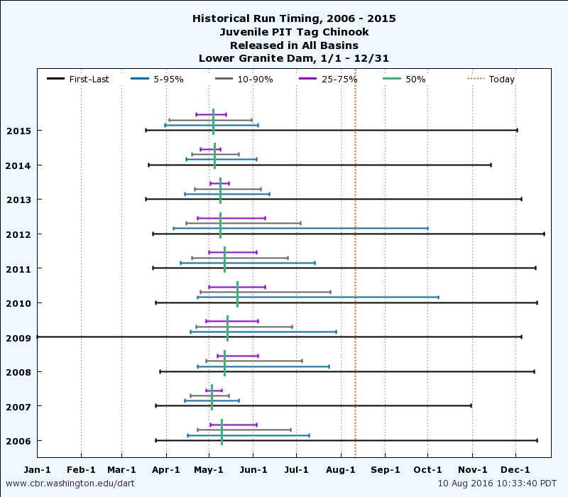
Figure 1. Historical juvenile chinook run timing through Lower Granite Dam based on PIT tag detection data.

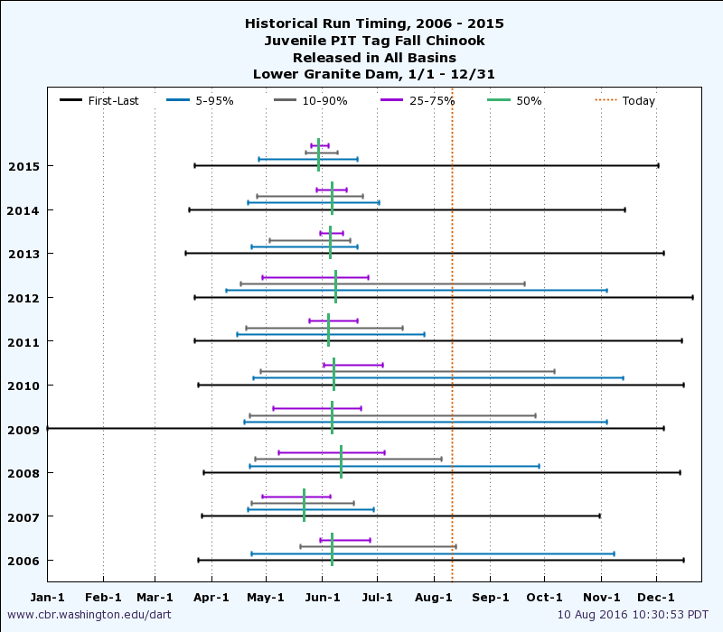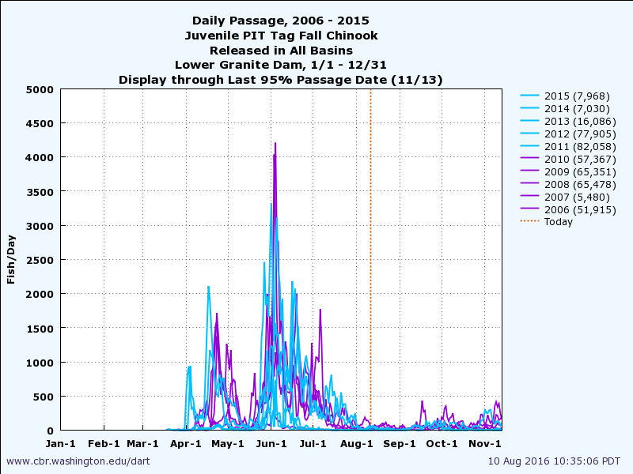
Figure 2. Historical juvenile fall chinook run timing through Lower Granite Dam based on PIT tag detection data.

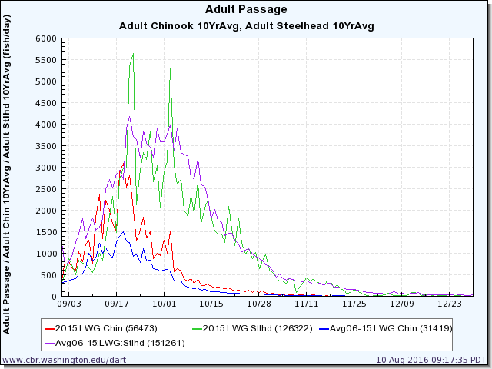
Figure 3. Historical adult salmon passage past Lower Granite Dam from 1 September to 31 December.

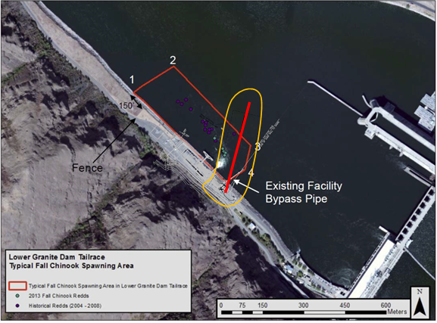
Figure 4. Typical fall Chinook spawning area in the Lower Granite Dam tailrace (area circled in dark red) and new primary bypass outfall construction area (area circled in yellow). The emergency bypass outfall will be constructed upstream of the existing facility bypass pipe where there has been no record of chinook spawning efforts.

Comments from agencies – The revisions to construction periods, work windows, and construction sequencing were presented to interested parties through a special FFDRWG meeting on 19 June 2016. All participating fish reps either concurred, or did not object, with the path forward as described herein including NOAA, CRITFC/CTUIR, ODFW, WDFW, and IDFG. No written comments were received from FFDRWG members that were unable to participate in the meeting.

Final results

Please email or call with questions or concerns.

Thank you,
David Trachtenbarg
Fish Biologist
Environmental Analysis Section
U.S. Army Corps of Engineers
Walla Walla District
201 N 3rd Ave.
Walla Walla, WA 99362
Phone: 509-527-7238

Figure 1 – Lower Granite Dam JBS Upgrade Schedule for August 2016 to March 2018
Table 1 – List of Activities and Memorandum’s of Coordination for Activities Associated with JBS Phase 1 Upgrade Activities
Activity | Start Date | Actual/Anticipated  End Date | Related MOC’s
Granite Phase 1A | October 2014 | March 2018 | 13 LWG 17  15 LWG 004
Mining Transportation Channel inside Dam |  | Fall 2017
Mining inside the dam | 12 May | Substantially complete spring 2016; limited additional mining through Fall 2017 | 15 LWG 002  15 LWG 010
Transportation Channel outside dam |  | January 2018
Drill and pour piers | March 2015 | Spring 2015 | 15 LWG 004  15 LWG 007
Fish Screen Slot Plugs | Oct 2014 | Oct 2015 | 13 LWG 022  15 LWG 001
Mining Collection Channel |  | Fall 2017
Units 1-3A | 1 Aug 2017 | Fall 2017 | 13 LWG 017  15 LWG 004  16 LWG 010
Units 3&4 widening | 15 Nov 2016 | 24 March 2017 | 16 LWG 010
Unit 5&6 widening | 1 Dec 2015 | 24 March 2016 | 13 LWG 17  15 LWG 007  15 LWG 023
Primary Dewatering Structure |  | Fall 2017
Drill and pour piers |  | Spring 2015 | 15 LWG 004  15 LWG 005  15 LWG 007
Transportation Flume |  | Fall 2017
Drill and pour piers | Winter 2015 |  | 13 LWG 17  15 LWG 004  15 LWG 005  15 LWG 007
Truss, Pipe, Flume Installation |  |  | 13 LWG 17
Secondary Dewatering Structure |  |  | 13 LWG 17
Crossover Activities | August 2017 | January 2018 | 15 LWG 025  16 LWG 010
On-shore Activites w/in JBS (e.g., tie-in flume to separator; tie-in transport flume to collection channel, tie-in primary dewaterer to existing systems, fill and convert downwell to emergency water supply) | August 2017 | January 2018
Remove existing outfall | 15 November 2017 | January 2018 | 15 LWG 025
Emergency Outfall Pipe (Phase 1a) | 15 Dec 2015  15 Nov 2016  15 Nov 2017 | 28 Feb 2016  28 Feb 2017  28 Feb 2018 | 13 LWG 17  15 LWG 025  16 LWG 010
Primary Outfall Pipe (Phase 1b) | 15 Nov 2016  15 Nov 2017 | 28 Feb 2017  28 Feb 2018 | 15 LWG 025  16 LWG 010
Government System Commissioning | Feb 2018 | March 2018 | 13 LWG 17  16 LWG 010

